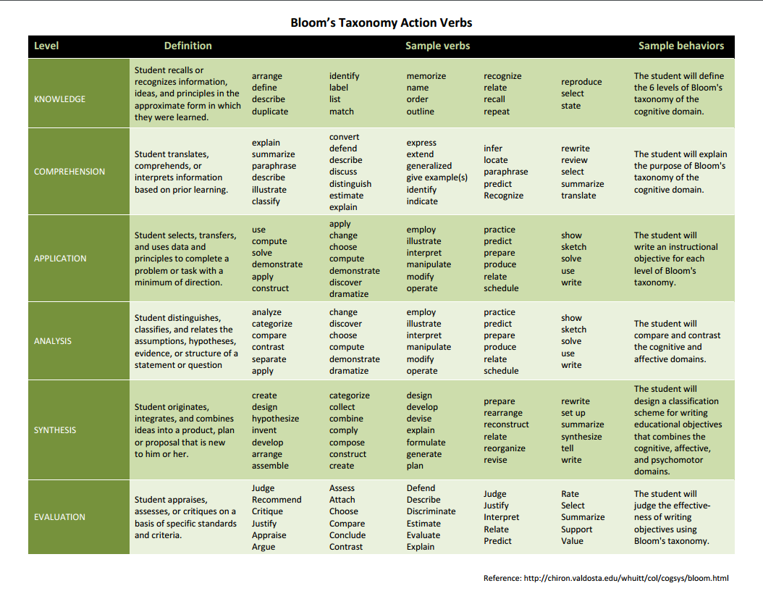
DECODE THE ASSIGNMENT

Choose one of the following assignments. You may want to choose the area you’re less familiar with.

Example 1: HUMANITIES/SOCIAL SCIENCES

Mateo is a first year student with little experience researching and writing essays. He has just received the following assignment.

You will prepare an annotated bibliography on the implications of a milestone event that took place in the first half of the 20th century. The items selected for your annotated bibliography will be used for your next assignment, the research paper. Your bibliography should include 10 recent items. It must include at least two scholarly journal articles which are not included in the course reading lists. Websites will not be accepted.

What will she need to know or learn in order to successfully complete the assignment?

Example 2: SCIENCE

Sangeet is one of over a thousand students in a second year life sciences class held in Convocation Hall. She has little research experience and her TA has just given her the following assignment.

Choose a topic of interest in the life sciences. Using an online database, print citation information, including the abstract, for five recent peer reviewed articles on your topic. Then choose one article, print out the first page and the bibliography, and write one paragraph explaining why you believe it is relevant to your topic.

What will she need to know or learn in order to successfully complete the assignment?

Assignment Planner
Learning Outcomes and Benefits  Choose from Bloom’s Taxonomy specific, active, and concrete language. | Assignment | Evaluation Criteria
Course learning outcomes | Type/genre: Be sure it aligns with the learning outcomes and describe its purpose, audience, and structure  - To inform, persuade, or synthesize?  - Expert or lay readers?  - Lab report, blog, proposal, white paper, summary, analysis, historiography, annotated bibliography, etc.) | Descriptive or quantitative?
Assignment learning outcomes  “For this assignment the student should be able to . . .” | Task(s)  Describe the steps and/or tasks students will need to take or avoid  e.g., conduct a literature review, interviews, etc. | Characteristics that will be included in the rubric: describe the things that graders will focus on
Benefits and/or Transferable Skills  Students will learn/get to practice …. Which will help them later with . . . | Scaffolding & Feedback  How you will scaffold it for the purpose ? (e.g., divide it into stages with progressively challenging tasks)  e.g., draft with peer review + revision + resubmission | Levels of competence: show and describe the number of levels, e.g., “excellent, good, satisfactory, needs work”
 | Resources you will include on the assignment instructions?  e.g., writing centres, data set, package of readings | Showing excellence: What examples will you show students and how will you show them?
NOTES:
_______________________________________________________________________________________________________________________________________________________________________________________________________________________________________________________________________________________________________________________________________________

Draft Evaluation Criteria for your proposed Assignment.
Ensure they connect well to your Learning Outcomes. Use these when you develop a rubric.

Developing Effective Assignments: Questions to Consider

- Learning outcomes.
  - What course goals or learning outcomes do you hope to advance through each assignment? Choose significant ones from your syllabus.
  - How do your assignments help your students achieve the learning outcomes you’ve set for your course?
- Type, Variety, and Level.
  - What types or genres of assignments will help students achieve #1?
  - Are you using a variety of assignments that target different outcomes?
  - Do your assignments reflect common genres in your discipline?
  - Are your assignments appropriate for the level of the course?

- Structure and Formative Feedback.
  - Are your assignments structured in ways that help students build on what they learn in your course?
  - Have you sequenced assignments so that they are progressively more difficult?
  - Do at least some of your assignments enable students to receive formative feedback, e.g., guidance on a draft?

- Workload and Timing.
  - Do your assignments give students an appropriate workload for the level and length of the course?
  - Have you spaced due dates at reasonable intervals rather than bunching them?

- Instructions, Delivery and Resources.
Have you
- clearly explained to students in writing the assignment purpose, task(s) involved, skills needed, and format guidelines and given the assignment a specific rather than generic name? e.g., “Article Review” rather than “Paper”
- given students opportunities to ask questions about the assignment?
- provided sample assignments or an explanation of common misunderstandings or problems students have had with similar assignments?
  - directed students to resources (e.g., TAs, librarians, writing centres, etc.)?
- Evaluation.
  - Will you (or your TAs) assess the process and/or the final product and if so how?
  - How long will the assignment take you (or your TAs) to grade and do you (or your TAs) have the necessary time and expertise?
  - Will you use a scoring guide or rubric for the assignment?
  - If you will use a rubric, will you involve TAs in developing the rubric?
  - Will you make the rubric available to students?
Ways to Get Better Student Writing and Less Plagiarism:
Course Design Strategies
- Set realistic tasks for students.
- Use a combination of in-class and out-of-class writing assignments.
- Give students opportunities to learn about and practice locating, reading, analyzing, and using sources, e.g., summarizing, paraphrasing, etc.
Avoid
- Over-assessment.
- Bunching assignments.
- Assigning one major end-of-term assignment without opportunities for feedback and revisions.
Assignment Design Strategies for Deterring Plagiarism
DO’s
- Make your assignments clear (by both “showing” and “telling”), focused, and unique.
- Show excerpts from student or professional work to demonstrate your expectations.
- Be specific about your objectives and expectations by giving detailed instructions and be sure to devote class time (and/or use an online discussion board) to answer questions.
- Give a list of narrow topics and/or sources and check out what’s available online on these topics.
- For large classes, change assignments slightly from section to section to discourage the exchange of assignments among friends in different sections (where students are likely to have different markers as well).
- Consider alternatives to the traditional research term paper such as case studies, field learning, etc. and give students an audience other than yourself, e.g., classmates or a decision-making body.
- Save the “classic” or most popular topics in your field for in-class writing exercises or exams and instead design assignments that take a fresh approach or give a new twist to an old topic.
- Structure your assignments so that students must prepare early on in the course and are rewarded for doing; in other words, include tasks that focus on process as well product.
This acknowledges students’ poor planning (in which they’re not alone!) and helps them start working before the last minute.
- Require topic proposals, up-to-date bibliographies (or annotated bibliographies), drafts or other work-in-progress.
- Use peer response (in lecture or tutorial) to get students talking about and/or writing assignments early.
- Set tasks that ask students for creativity, analysis, evaluation, and synthesis rather than merely information gathering.
Plagiarists are good at finding sources to copy from. Capitalize on this by having them
i) identify several sources that provide an answer to a particular question, and then compare them, and explain which is the best source, and why; or
ii) locate and then manipulate information in a particular way.
- Explain and discuss your institution’s academic integrity policy, but also the positive reasons for and benefits of correct citation practices.
Many students don’t realize that citing sources appropriately strengthens their writing and shows that they’re joining the scholarly conversation.
- Stress the positive: when we as academics cite the work of colleagues, our primary motive is not to avoid accusations of plagiarism, but to establish our credibility, advertise our allegiances, bring work to the reader’s attention, exemplify contending positions, etc., all of which are positive motives.
- Help students understand that good academic writing is a conversation and show them that they can only join the conversation by learning how to read for the sense of an entire chapter or article, rather than just for quotable quotes.
- If you want your students to cite in a particular way, direct them to resources them that will help them do this. Even if you’re unconcerned about which citation style students use, specify one to make it easier for your TAs to respond to and evaluate student writing.
- Limit the range of acceptable sources, whether to course readings, one or more sources published within the last year, or published books and peer-reviewed journals that require your prior approval.

- Be flexible about the level of stylistic competence you expect; make it clear, especially to English Language Learners, that they won’t be unduly penalized for the poor grammar and syntax that often result from writing in their own voice.
- Explain and model your own use of sources in lectures, class discussions, and handouts.
Explicitly model how to use sources appropriately and point this out to students (once every lecture), e.g., “Note that I’ve done here what I’m asking you to do in your papers—agreed with one aspect of Freud’s argument, but then extended or complicated it to develop my own idea.”
Don’ts
- Try not to ask exactly the same question or set the identical task twice. (We don’t allow students to receive credit for previously submitted work so why not hold ourselves to the same standard and avoid recycling assignments?)
- Avoid assigning completely open-ended topics/questions. These kinds of assignments unfortunately present endless opportunities for students to plagiarize and the lack of guidance or boundaries can be daunting for inexperienced students.
REFLECTING ON ASSIGNMENT DESIGN
Read the handouts on assignment design and review your assignment plan. Consider the specific challenges for your discipline—does your assignment design help address these?

_______________________________________________________________________________________________________________________________________________________________________________________________________________________________________________________________________________________________________________________________________________

Also consider, are there strategies not included in the handouts that you’ve found effective in addressing these challenges or that you’d like to try?

________________________________________________________________________________________________________________________________________________________________________________________________________________________________________________________________________

Rubrics: An Effective and Efficient Grading Tool for You and Your TAs
“a rubric is a scoring tool that lays out the specific expectations for an assignment” (Steven and Levi, 3).
The Basic Parts of a Rubric
- A task description (the assignment), e.g., “Write a 2-page editorial.”
- A scale of some sort indicating levels of achievement.
- Dimensions of the assignment (a break-down of the skills/knowledge involved in the assignment such as “analysis, factual content, grammar,” etc.).
- Descriptions of what constitutes each level of performance (specific feedback) laid out in a grid.
Benefits of Rubrics
- Make grading more consistent and fair (especially when TAs are grading)
- Save time and enable more timely feedback to students
- Give students more detailed feedback
- Clarify instructor expectations to students (if you share rubric with students ahead of time)
- Diagnose students’ strengths and weaknesses and help us refine our teaching methods
- Full rubrics provide explicit guidance for teaching and for students’ peer review and self-checking

Steps for Constructing a Rubric
If possible, work from examples of past student performances, grading checklists, descriptions of criteria, comments on assignments or tests—and anything else that has helped you in the past to articulate criteria for student performance.
- Reflect. Choose a test or assignment that tests what you want to evaluate. Consider your objectives for the assignment (what you want students to learn and do), why you created the assignment, what happened the last time you gave it, and what your expectations are.
- List. Identify the criteria or “traits” that will count in the evaluation such as “thesis,” “use of concepts,” “factual accuracy,” etc.
- Group and Label. For each trait, construct a two- to five-point scale using descriptive statements.* For example, if the trait is “thesis,” then the scale for “thesis” will have several levels, each with a description of the performance for that level. For example, a thesis that scores a 5 does X, Y, Z. A thesis scores a 4 does X and Y, etc.
- Apply. Try out the scale by applying the dimensions and descriptions form Stage 3 to a sample of student work; review with colleagues or TAs and revise.
*TIP: Avoid overly negative vocabulary in your scale words, e.g., “failed to . . .,” which can discourage students and instead use words that guide students towards exemplary performance, e.g., “exemplary, competent, beginning;”
“excellent, good, developing;” “strong, satisfactory, needs work”
Benefits of Collaborating on Rubrics
- Provides us with more input about how we communicate our expectations
- Provides your department with a better record of shared expectations, continuity, and academic standards
- Provide individual instructors with evidence of their own teaching skills
- Constructing a rubric requires knowing what is and is not important for each assignment and for the class overall, which can help TAs become better at leading tutorials, marking, etc.
- TAs are generally closer to the students and can offer insights into what needs to be spelled out and what doesn’t
- Avoids problems that result from simply handing a stack of assignments to a TA without offering guidelines about how they are to be graded

Ways to involve TAs in constructing rubrics (adapted from Stevens and Levi, 2005).
- Instructor creates rubric and gives it to TAs to use in grading
- Instructor creates list of the basic dimensions and main points but lets TA create rubric; instructor checks rubric and revises it before allowing it to be used for grading
- Instructor creates a list of goals and key points and lets TAs create rubric; the instructor checks rubric and revises it before allowing it to be used for grading.
- Instructor tells TAs to create rubric, but checks it and makes changes before it is used for grading.
Other useful potential collaborators for rubrics:
Colleagues, librarians, Writing Centre Instructors, etc.

For further reading on rubrics . . .
Dannelle D. Stevens and Antonia J. Levi, Introduction to Rubrics: An Assessment Tool to Save Grading Time, Convey Effective Feedback and Promote Learning.
John James Mora, “Rubrics as an evaluation tool in Economics” (March 1, 2010). Available at SSRN: http://ssrn.com/abstract=1578439 or http://dx.doi.org/10.2139/ssrn.1578439

Metarubric: How to evaluate the overall quality of your rubric.

Rubric Part | Evaluation Criteria | Yes | No
Dimensions | Does each dimension cover important parts of the final student performance?  Does the dimension capture some key themes in your teaching?  Are the dimensions clear?  Are the dimensions distinctly different from each other?  Do the dimensions represent skills that the student knows something about already? (e.g., analysis)
Descriptions | Do the descriptions match the dimensions?  Are the descriptions clear and different from each other?  If you used points, is there a clear basis for assigning points for each dimension?  If using a three- to five-level rubric, are the descriptions appropriately and equally waited across the three-to-five levels?
Scale | Do the descriptors under each level truly represent that level of performance?  Are the scale labels (e.g., exemplary, competent, beginning) encouraging and still quite informative without being negative and discouraging?  Doe the rubric have a reasonable number of levels for the complexity of the assignment and level of the course?
Overall Rubric | Does the rubric clearly connect to the outcomes that it is designed to measure?  Can the rubric be understood by external audiences (avoids jargon and technical language)?  Does it reflect teachable skills?  Does the rubric reward or penalize students based on skills unrelated to the outcome being measured that you have not taught?  Does the rubric include the assignment description or title?  Does the rubric address the student’s performance as a developmental task?  Does the rubric inform the student about the evaluation procedures when their work is scored?  Does the rubric emphasize the appraisal of individual or group performance and indicate ways to improve?
Fairness | Does it look like the rubric will be fair to all students and free of bias?  Does it look like it will be useful to students as performance feedback?  Is the rubric practical for the kind of assignment?  Does the rubric make sense to the reader?
(Stevens & Levi, 94)

 | Excellent | Good | Competent | Problematic | Pts
Main argument & economic concept | 13  Very clear explanation of main argument and key economic concepts. All the key points and supporting evidence are included. | 10  Fairly clear and concise explanation of main argument and key economic concepts. Most key points and evidence are included. | 8  Summary of main argument and explanation of key economic concepts could be clearer. Some key points and relevant evidence are included. | 6  Problems summarizing main argument and explaining key economic concepts. Missing key evidence. | 15
Organization | 4  Logical order of ideas. Excellent paragraph structure and very clear topic sentences. | 3  Mostly logical order of ideas. Good paragraph structure with fairly clear topic sentences. | 2  Somewhat logical order of ideas. OK paragraph structure but topic sentences could be clearer. | 1  Confusing order of ideas. Illogical or inconsistent paragraph structure and topic sentences. | 5
Quality of writing | 4  Clear, correct, and concise sentences. Very few errors and none that impede meaning. | 3  Mostly clear, correct, and concise sentences. A few errors but they don’t impede meaning much if at all. | 2  Some problems with clarity, concision, and correctness at the sentence level. Some errors that impede meaning. | 1  Many problems with clarity, concision, and correctness at the sentence level. Many errors that impede meaning. | 4
Total |  |  |  |  | 24
Comments
A strength of this abstract is:

The most important thing you need to work on for the next assignment is:

First-year Economics
First-Year Anthropology
Student Name: ________________________________________ Student Number:_______________________
CRITERIA | Needs Work | Adequate | Good | Excellent
1. ANALYSIS AND ARGUMENTATION
- Defines scope of paper in response to given topic (clearly defined or overly broad?)
- Formulates precise research question and thesis or position as appropriate
- Uses evidence to support analysis and argument (detailed and specific?)
- Acknowledges and addresses possible counter arguments to, and gaps in evidence for, own position
- Shows critical understanding of sources, including examination of authors’ assumptions

2. ORGANIZATION AND QUALITY OF WRITING
- Introduction and conclusion concisely set out focus and scope of essay (not too broad and/or rambling)
- Essay presents ideas in logical and coherent paragraph structure and uses clear sentence structure
- Consistent focus on topic throughout with no irrelevant points
- Ideas expressed clearly, precisely, and convincingly, yet concisely (avoids unnecessary words)
- Technical “jargon” is used with precision and only where ordinary language would not suffice

3. CHOICE AND USE OF SOURCES
- Builds on required reading
- Fulfils requirements (scholarly sources only, one refereed journal article, no websites)
- Integrates sources throughout essay
- Uses in-text citations correctly; correct use of AAA style in Reference List
COMMENTS
1 – The revisions from the Advanced Draft Essay are (very well done / an improvement / inadequate) because:
2 – The paper’s strongest points are:
3 – The paper lost marks mainly for:

Essay Grade:
Late Marks Deducted:
Final Essay Grade (/100):

1st Year Political Science

Student Name: |  |  | Graded By:
 |  | Comments
Thesis and Arguments
Evidence and Use of Course Material
Structure/Organization and Writing Style
Strength(s): |  |  | Weakness(es):
Grade: | Other Comments:

Lab Report Rubric for a FY Biology Course
 | (4 pts) | (3 pts) | (2 pts) | (1 pt) | (0)
Introduction | 1. Includes the question to be answered by the lab  2. states hypothesis that is based on research and/or sound reasoning  3. title is relevant.  4. Hypothesis (prediction) is testable. | One of the "excellent" conditions is not met | Two of the "excellent" conditions is not met | Three of the "excellent" conditions is not met
Methods |  |  | A description or step-by-step list of how the experiment was performed | Description unclear, couldn't be repeated
Results (data) | Results and data are clearly recorded, organized so it is easy for the reader to see trends. All appropriate labels are included | Results are clear and labeled, trends are not obvious, | Results are unclear, missing labels, trends are not obvious at all | Results are present, though too disorganized or poorly recorded to make sense of
Analysis | The data and observations are analyzed accurately, trends are noted, enough data was taken to establish conclusion | Analysis somewhat lacking in insight, enough data, though additional data would be more powerful | Analysis lacking in insight, not enough data was gathered to establish trends, OR analysis does not follow data | Analysis poor, not enough data, inaccurate analysis
Conclusions | 1. Summarizes the essential data used to draw conclusions  2. Conclusions follow data (not wild guesses or leaps of logic),  3. Discusses applications of experiment ("real world" connections)  4. Hypothesis is rejected or accepted based on the data. | One of the "excellent" conditions is not met | Two of the "excellent" conditions is not met | Three of the "excellent" conditions is not met
Format |  |  | Neat, organized with headings, few spelling/grammar errors | Somewhat lacking in organization, multiple spelling/grammar errors, not neat

Assignment Design - The Student Perspective
What Students need on assignments:
- The purpose and goal of the assignment
- Course context, how the assignment fits in and what it builds from
- Clarity
- Tangible expectations
- Transparency in criteria
- Examples and exemplars
- Pre-requisite skills and thinking – ask yourself what is the pre-requisite skill or thinking required for this? Are they likely to have it? Can you build the learning in?
- Deadlines
- Help
- Resources
- Opportunities for question and answers
- Assignment handout readability: font, format and layout on the page, sections, task-ability
Students struggle with:
- Getting started
- Knowing where to start
- Breaking things down
- Being unaware of support and research services
- Underestimating the value of process
- Time management with competing deadlines
- Trying to compose before attempting pre-writing activities
- Managing week-to-week work with assignments and tests
- Lengthy, detailed assignment descriptions and short non-detailed assignment descriptions
- Weak/still developing pre-requisite skills
- Lack of understanding or experience with the ideal product
Students benefit from:
- Scaffolded or building block or broken down assignments
- Learning to project manage (backwards plan) their work
- Learning to break down the work and identify tasks
- Visual as well as text representations of the assignment when possible
- Approachable TAs and Profs
- Challenging, specific research questions
- Thinking questions (to prompt)
- Writing assignments of different lengths including frequent, shorter assignments with feedback rather than one large assignment
- Specificity – but not overwhelming detail – in the assignment and rubric
- Detailed feedback
Wrap-Up
3 Things you have learned about designing assignments.
1.

2.

3.

2 Next steps you will take in designing or redesigning an assignment.

1.

2.

