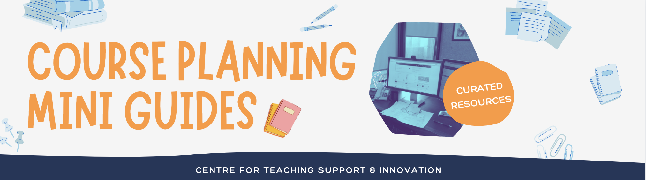 | Reflection &  Planning  Worksheet  Make your engagement with the CTSI Course Planning Mini Guides more meaningful by using the prompts below to reflect and plan how you’ll use your learning.

Content Item | Why did you choose this item? What challenge or situation in your teaching are you hoping to address? | What did you learn that was new or surprising? What made it stand out? | What’s one new strategy you could take back to your teaching? What might you recommend to a peer? | What’s something you still want to learn more about? Where might you find more information?
e.g. Assessing Student Work and Providing Feedback in Quercus-Part I | e.g. I want to add new types of assessments to my course, but I’m not sure how to integrate them into Quercus | e.g. I didn’t know that I could provide voice or video feedback in SpeedGrader. This could be a new way to communicate tone. | e.g. I’m going to start including an Academic Integrity statement as a first question on my quizzes | e.g. I want to learn more about the settings available for quizzes, so I’m going to try out the Template Course
(Add rows as needed)

